Class Diagram

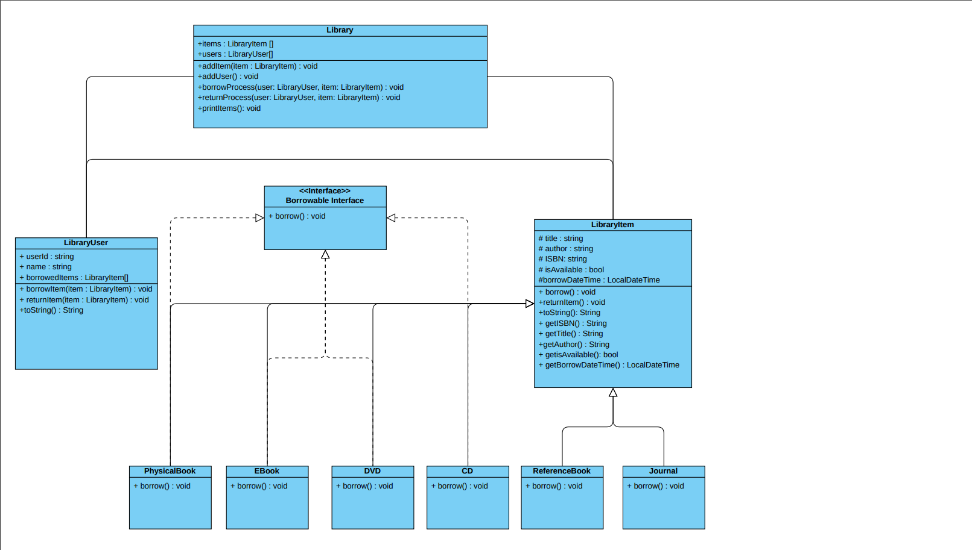

Report

|  |  |  |  |
| --- | --- | --- | --- |
| Input | Output | Result | Pass or Fail |
| Title : Programming 1  Author : Bill Gates  ISBN : 99-9999  Type : Physical Book | Massage with item details and that item has been added | Massage with item details and that item has been added |  |
| Click on borrow Item  User Id : 20236094  Name : Mostafa Raafat  Click on the desired item  Click borrow | Massage with item details and has been borrowed with user details | Massage with item details and has been borrowed with user details |  |
| Click on Return Item  Click on the user desired  Choose Item to be returned  Click Return Item | Massage that Item has been returned | Massage that Item has been returned |  |
| Click on borrow Item  User Id : 20236103  Name : Moneer Magdy  Click on an unborrowable item  Click borrow | Massage that the item is not available to borrow | Massage that the item is not available to borrow |  |
| Click on item list | All items in the system must be shown with their current state | All items in the system must be shown with their current state |  |

ScreenShots

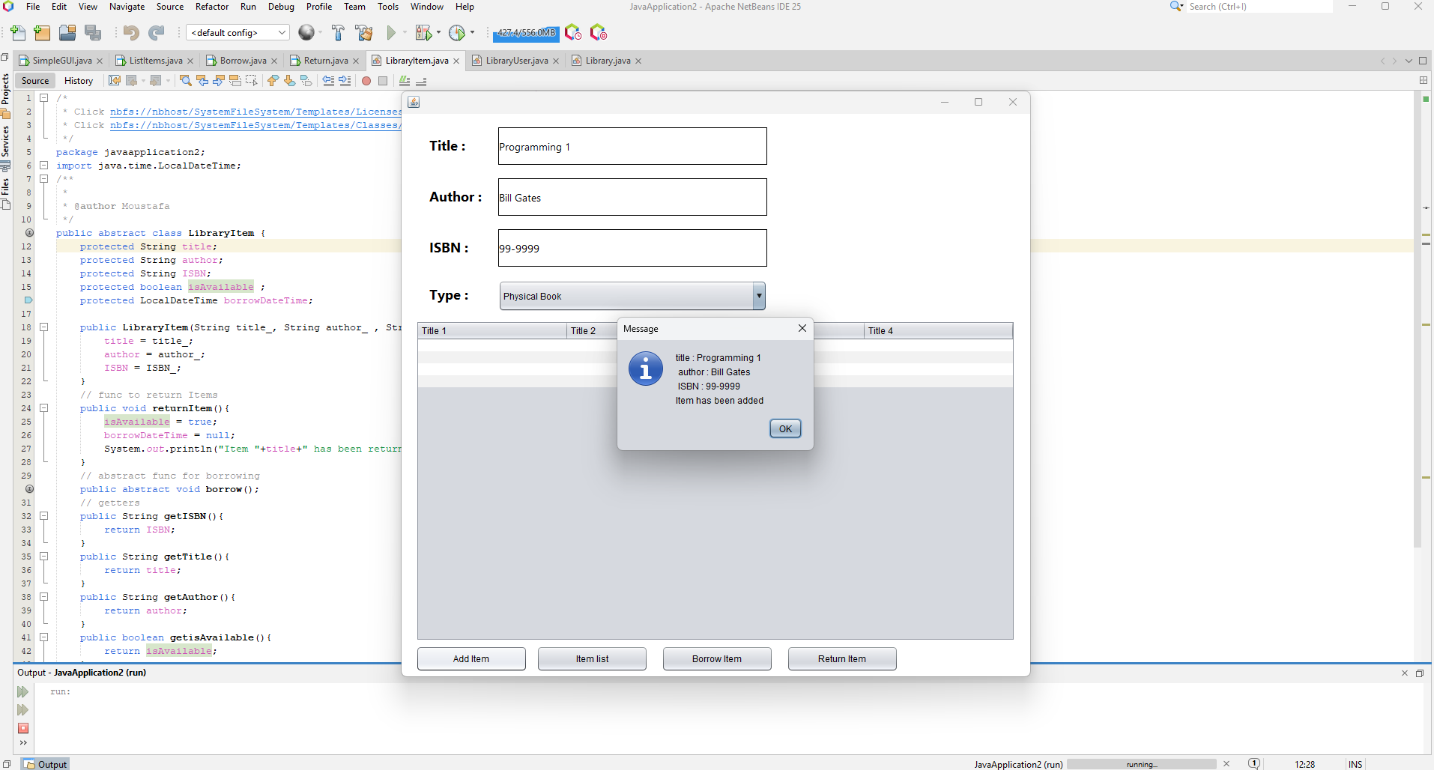Test Case 1:

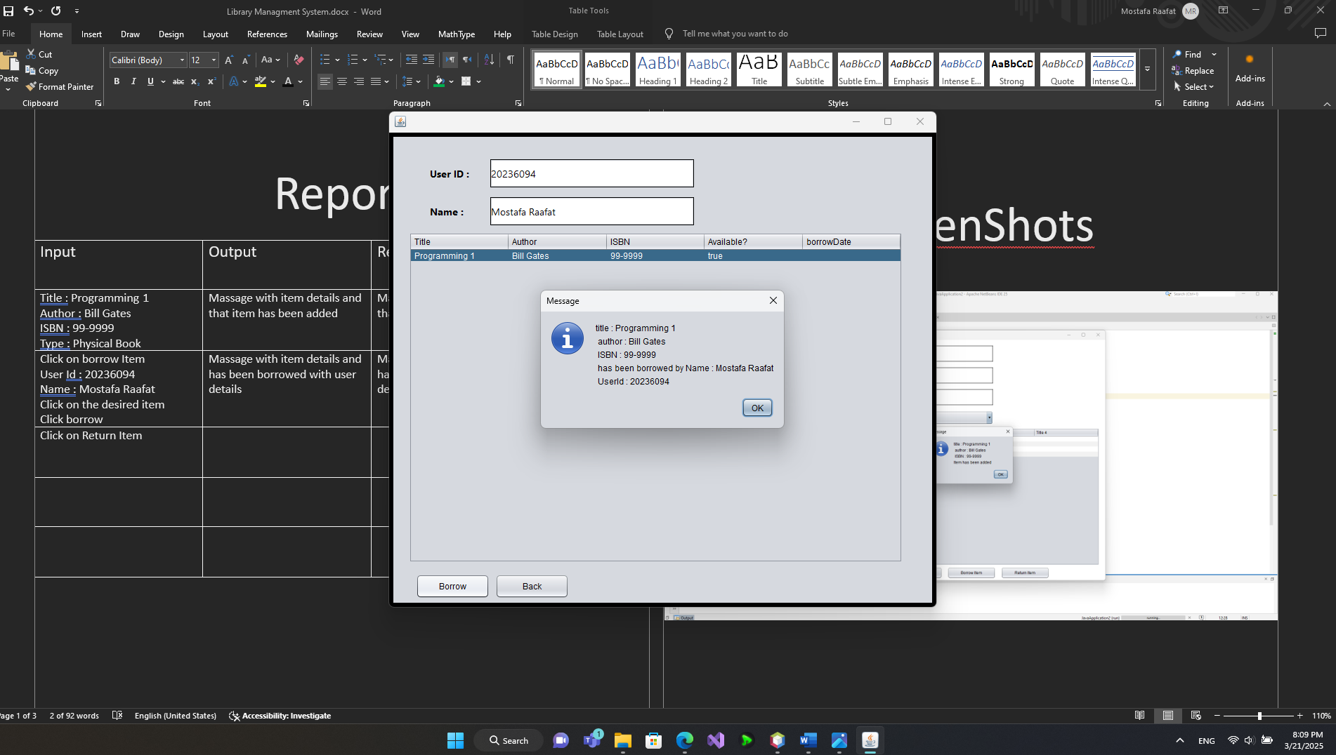Test Case 2 :

Test Case 3 :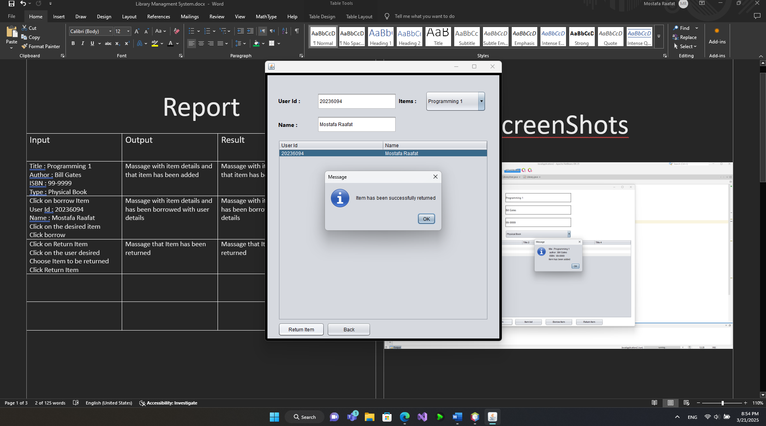

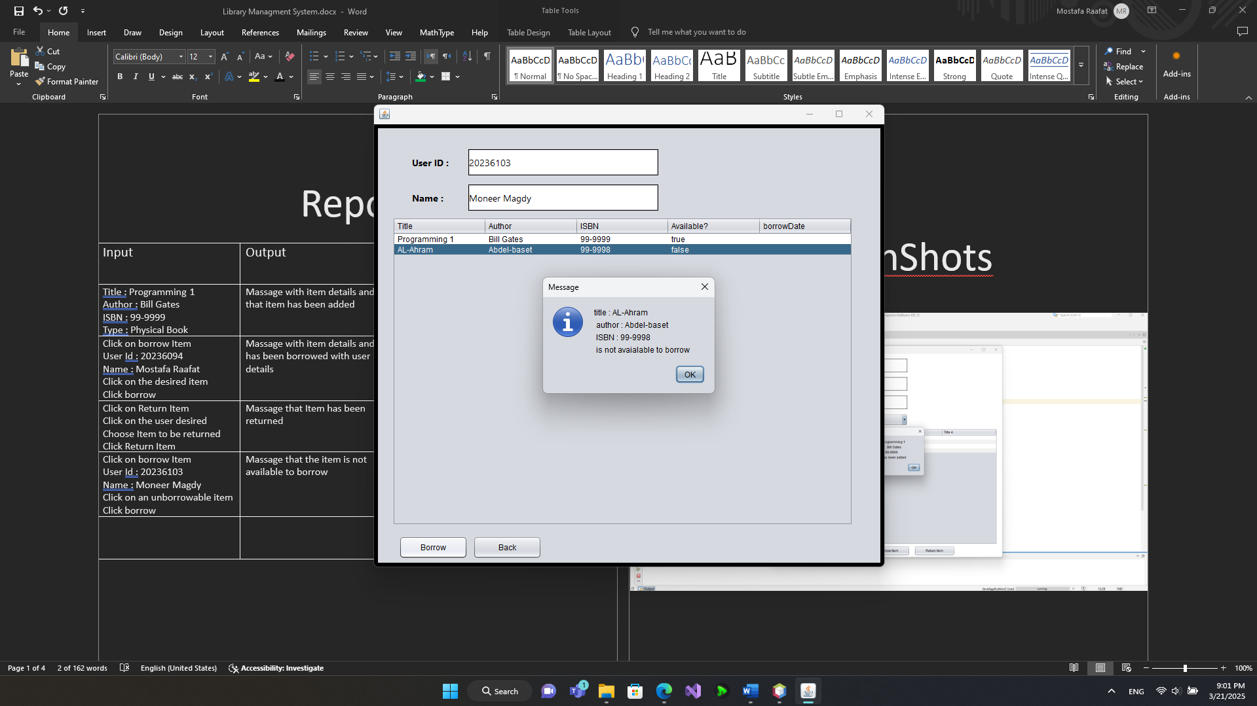Test Cases 4:

Test Case 5 :

